VIEW INVENTORY SCREEN.

* Must be able to view a summary of the current inventory of the firm’s products.
* Must be able to register new items to the inventory by scanning the barcode of the item.
* Must be able to view deactivated products (with note on why it was deactivated.

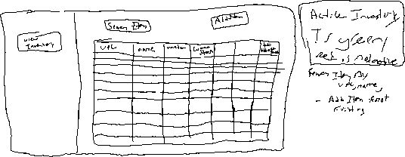

CLICK ON ROW FOR MODAL THAT DOES THE FOLLOWING:

* Must be able to edit a product’s metadata, including size, categories, and variations of the product.
* **Manager** must be able to delete (deactivate) an item from the inventory but maintain the item data. (have optional note added why)

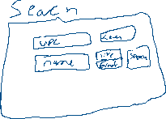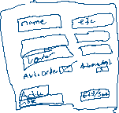

ADD ITEM QUANTITY

* Must be able to restock items in the inventory by scanning the barcode of the item.
* Using barcode, auto adds 1 item or ( optional quantity field)

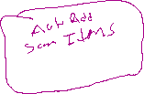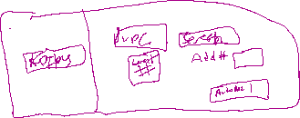

REMOVE ITEM QUANTITY

* Must be able to “sell” items in the inventory by scanning the barcode of the item.



* Using barcode, auto removes ( optional quantity field)

AUDIT Store Quantity

* Select item using barcode. (click audit button, locks in the upc
* Shows current stock.
* Shows counter from barcode ( also manual entry field, with confirmation override.
* Click button to lock in the audit number, then validates the amount with user information on (audit number is more, less or equal to the db)

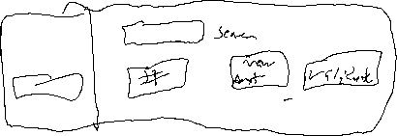

Vendor Management

LOGIN FORM

* Must be able to register a new firm.
* Must be able to register a new user with one time pass generated by Store’s admin or manager.

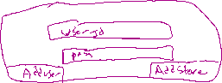

MANAGEMENT COMMAND

Manager Overview tab

* Lets manager/admin see who has sold a specific item and when. They can see the current stock level that the db had after the item was sold.
* They can see all items sold, added stocks
* An admin must be able to start a new order sheet.



* An admin must be able to add items an existing order sheet.

User Management (only Correct users see this)

* An admin must be able to delete an existing user.

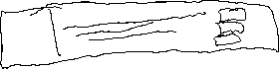

SYSTEM OVERVIEW

* Might be able to send notifications via email when the inventory count of a product drops below 5.

